7.2.1: Describe two best practices successfully implemented by the Institution as per NAAC format provided in the Manual
1) Title of the Practice No.01
Local Bank Visit
2) Objectives of the Practice
1. To review about the understanding financial transactions.
2. To Help Students to understand the information about exchange.
3. To Guide Students about Various Deposits.
4. To Guide and Information of Financial Planning.

3) The Context:
V.K. Chavan- Patil College run by Sharada Prasark Mandal. The V.K.C.P College organized visit to the New Navhind Multipurpose Co-Society for understanding the work of Co-Society. This activity help among the student to understand the information about exchange of bank.
4) The Practice:
This activity is useful for the Students. The Students Understand Financial transactions and also get information about the exchange. Students get guidance about various deposits and help in financial planning. Training programme was conducted for the students.
5) Evidence of Success :
Sr. No | Name | Visit Date | Year | No of Students
1 | New Navhind Multipurpose Co-Society | 5 March | 2018 | 10
2 | New Navhind Multipurpose Co-Society | 23 Sept | 2019 | 07
3 | The Ajara Urben Bank | 17 Oct | 2021 | 06
4 | New Navhind Multipurpose Co-Society | 19 Jan | 2022 | 07
5 | Jansampda gramin Bigar Sheti Sahkari Sanstha | 20 May | 2023 | 09

 | 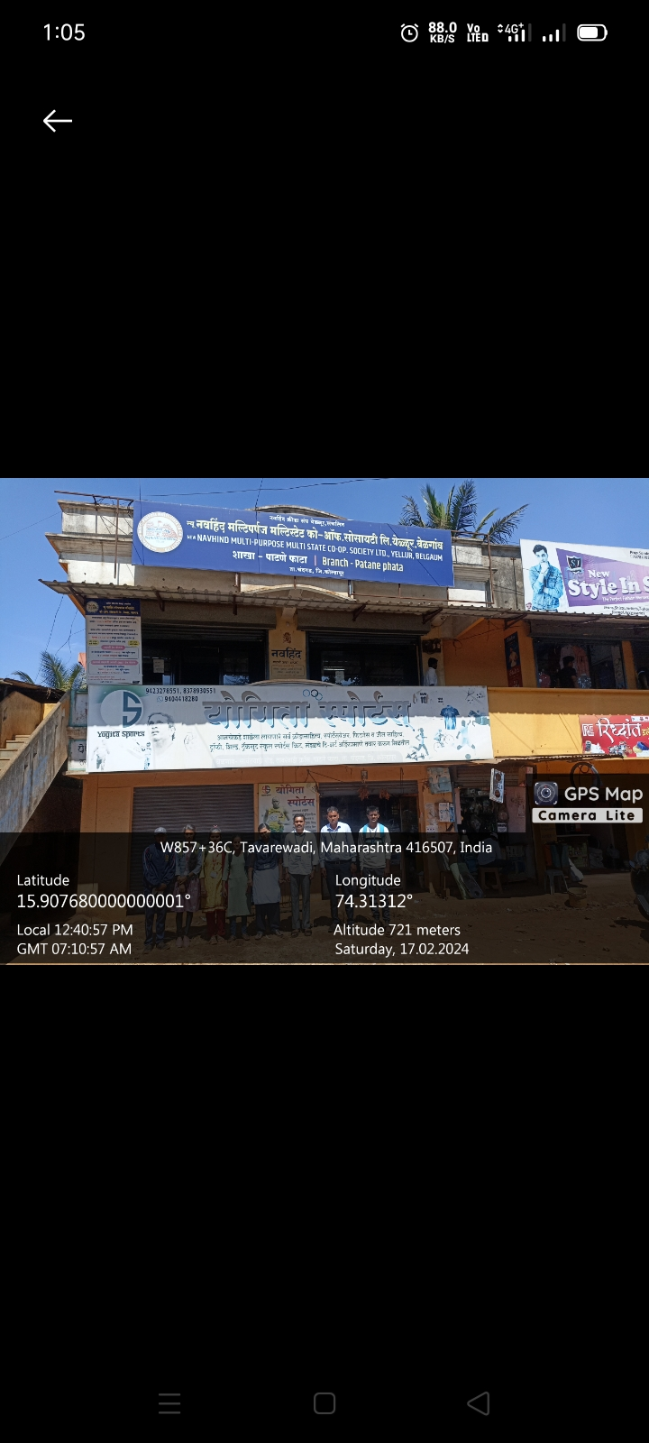
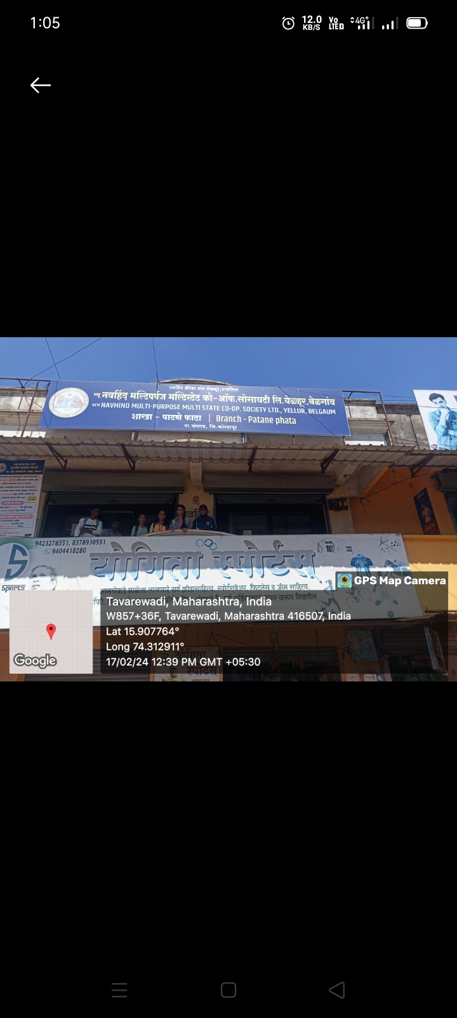
6) Problems:
As students are not aware of bank transactions and processes of bank management. Therefore, this practice is useful to students about the bank awareness.
7) Notes:
This Practice is useful for student for understanding bank process. Student also benefited about the future Plan of Investment.
Principle
1) Title of the Practice No.02
Plantation of Historical Fort Kalanidhigad
2) Objectives of the Practice
1. Tree Plantation of historical fort Kalanidhigad.
2. To provide historical information among the student.
3. To arrange nature study tour at Kalanidhigad
4. To Protect and Conserve historical site of Kalanidhigad.
2. Planning and Preserving Trees.

3) The Context:
Kalanidhigad is located in Chandgad tehsil of Kolhapur district. The distance of Kalanidhigad of 13 Km from Collage Campus and it is 140 km from Kolhapur and 35 km from Belgaon.. This hill fort known by various names like Kalanidhigad, Kalanandigad or Kaalanandigad. The size of this fort was small and easy climb therefore this fort is easily accessible by trekkers. The geographical environment of this fort is good.

4) The Practice:
Every year college student conduct the drive of tree plantation Kalanidhigad. The practice students make aware the historical importance of Kalanidhigad. To create the awareness about the Conservation of fort. Cleanness drive was arranged for Kalanidhigad. For the surrounding environment tree plantation and cleanness drive organized. Every year 19th Feb celebrating Chhatrapati Shivaji Maharaj Jayanti. This is the best practice of our students.

5) Evidence of Success:
Every years students visits the Kalanidhigad and plantation and clean this areas. Every year 19th Feb celebrating Chhatrapati Shivaji Maharaj Jayanti. This is the best practice of our students.
Sr. No | Name | Visit Date | Year | No of Students
1 | Kalanidhigad | 6 June | 2018 | 56
2 | Kalanidhigad | 19 Feb | 2019 | 56
3 | Kalanidhigad | 6 June | 2021 | 56
4 | Kalanidhigad | 19 Feb | 2022 | 56
5 | Kalanidhigad | 6 June | 2023 | 52

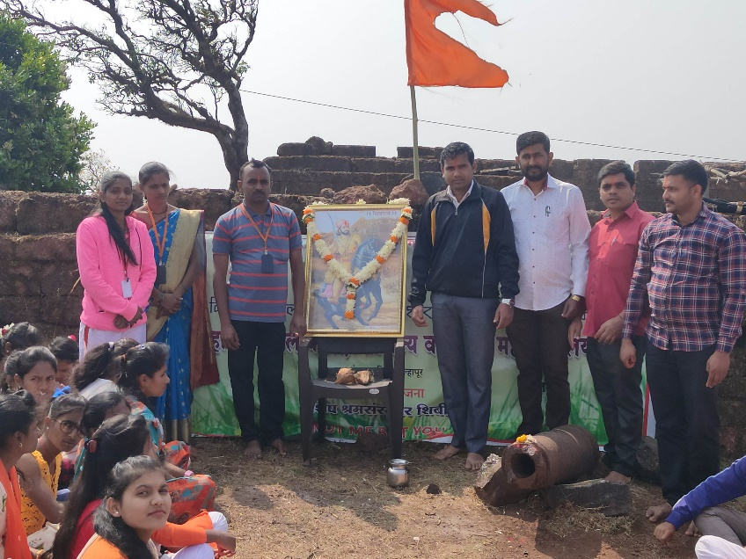 | 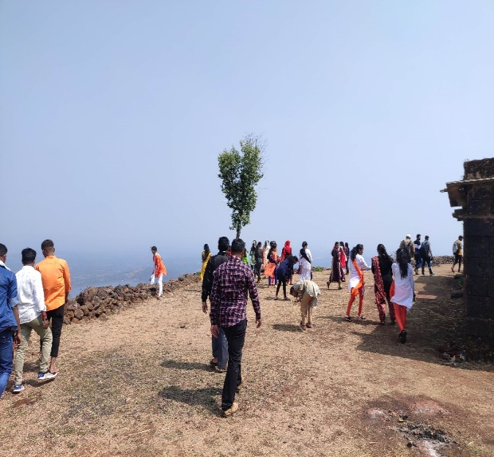
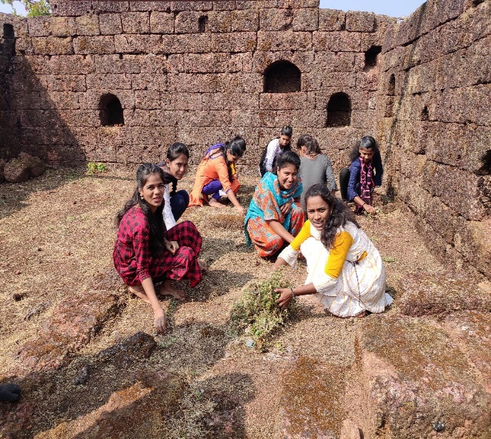 | 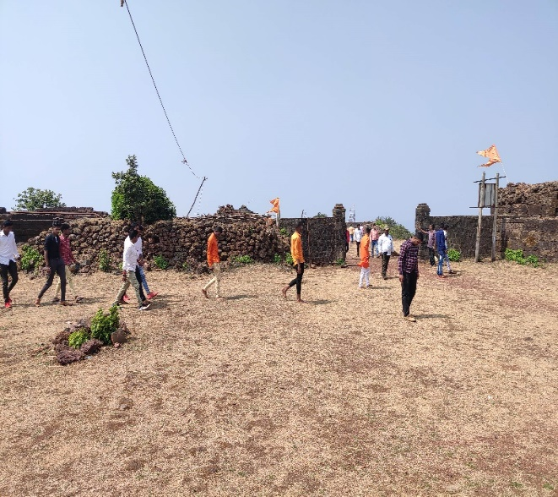

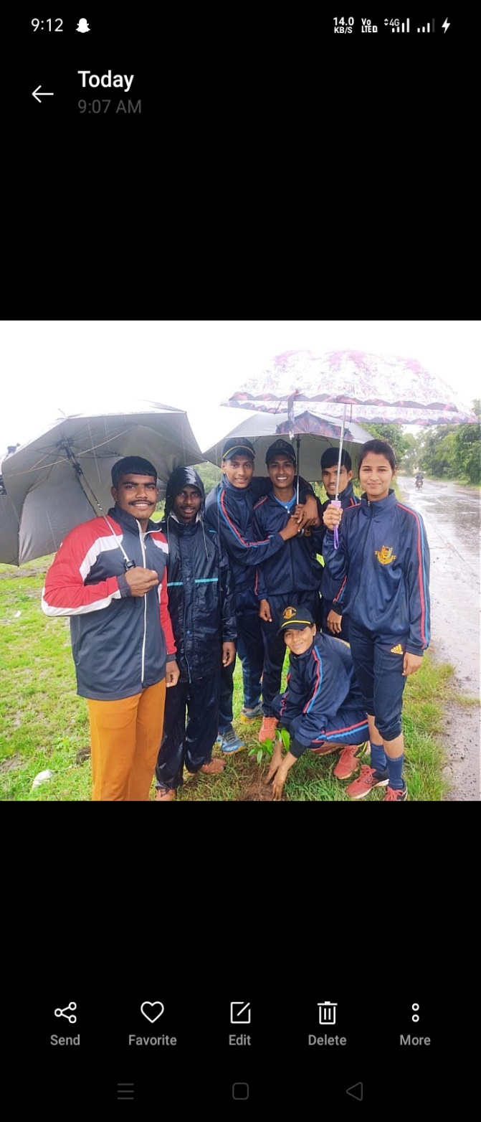 | 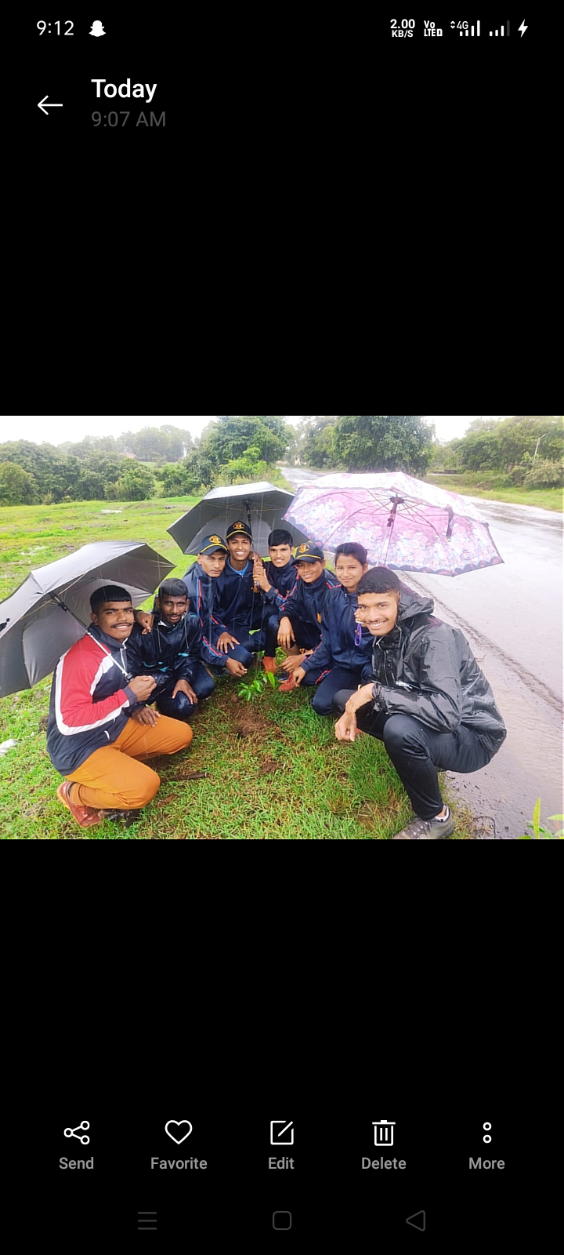
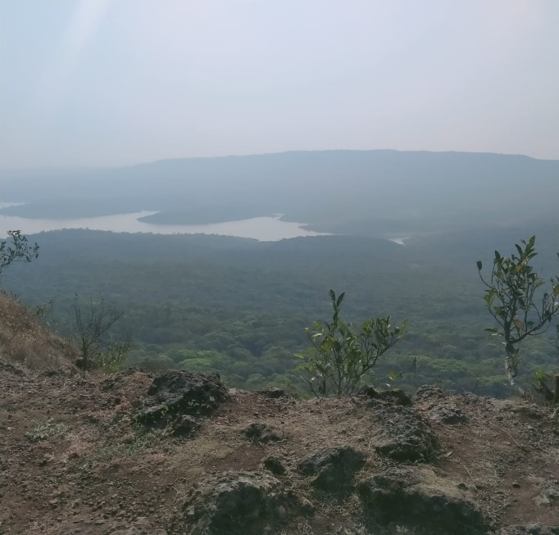 | 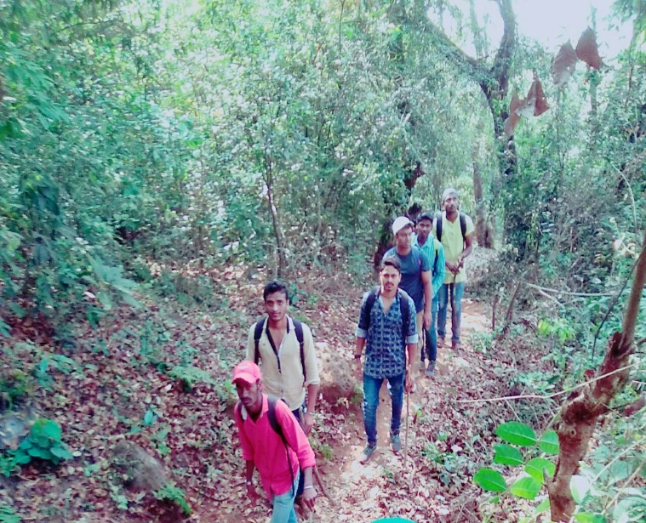
6) Problems:
Due to the unsanitary nature of fort, it is because they are not aware of conservation
7) Notes:
This practice inculcates the constitutional value of plantation.

Principle

